Interview Brief:
“Hello, I am a DECO3500 Social and Mobile computing student and today I will be asking you interview questions about your experiences at large scale music festivals

As a team, we are looking to enhance the experience of audience members at large music festivals (2+ concurrent stages playing music), through interactive tools that help form new connections amongst strangers and/or support friends in coordinating, locating, and communicating with each other.

Confirming I have your permission to record your voice.
If at any point you feel uncomfortable, please don't feel the need to answer.
Let's begin!”

Interview Questions:

Intro and background:
- How old are you and what is your occupation?
- What genre of music do you listen to?

General festival occurrence:
- Roughly how many large scale music festivals have you been to and how recently were they?
- What was the most recent music concert that you have been to?
- What draws you to music festivals?
- Was there a time a music festival wasn't what you expected? What happened and why?
- In general what was the most valuable experience you had with your friends (outside of a festival)

Festival Environment:
- Who do you usually go with? (If they go to music festivals with friends) Other than music festivals, what other events/activities do you guys participate in as a group?
- Does the number of people you’ve attended the music festival change through the event? And Explain
- Can you recall the most recent time you connected with a stranger at a festival or have you ever felt invited to connect with a stranger? Tell us about this experience.
- Do you have a buddy that you stay with the entire festival, or does the buddy change?
- Tell us about your most recent music festival experience
- What do you currently do to find friends again if you get separated?
- What would make you feel more comfortable approaching or being approached by a stranger at a festival?

Festival Agenda:
- Walk me through how you and your group usually plan to meet up or split up during a day at a festival
- Describe your ideal music festival day/experience
- What do you typically do before a music festival?
- What do you typically do after a music festival?
- Has your phone or network connection ever failed you at a festival? What happened?

Other:
- What's the most frustrating part of the whole festival experience for you?
- What are your priorities when going to a music festival?
- Would you be more open to different kinds of interactions/ talking to strangers during your time in between sets or stages??

Thank you for your time and for participating in our interview.

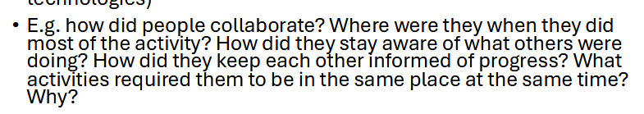
From WK4 - pg 13 slides

Think extremes to get stories:

Best, worst.
Longest, shortest

Additional questions - positioning and location in crowd and music table
Where do you usually position yourself in a crowd or mosh (front, middle, back, edges)? What drives that choice?
Does your spot in the crowd change over the course of a set, or do you stay put? Walk me through why.
Have you ever taken part in an interactive or collaborative installation at a festival, physical or digital? What was that like?
Imagine a shared table where each spot is a different musical note, and moving objects around the table builds a song collaboratively - would that appeal to you? Why or why not?

